The functionality of the MATLAB script to extract data from RGB channels for image analysis is described below in the walkthrough.

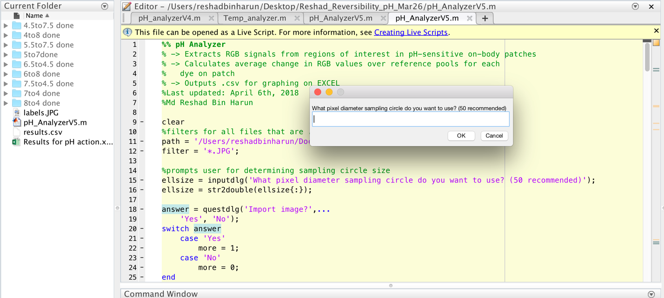

1. The program asks the user to determine the size of the sampling circle to be used. A larger sampling circle provides a better average, but the most relevant regions are in the central part of the pools.

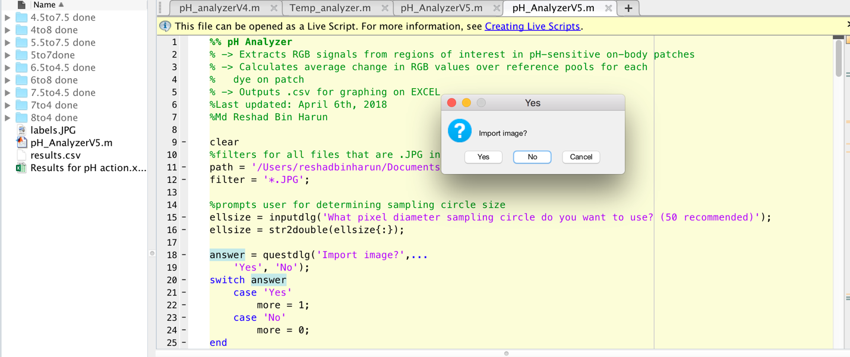

1. Once the sampling circle size is determined, the user is asked if they want to import an image for analysis.

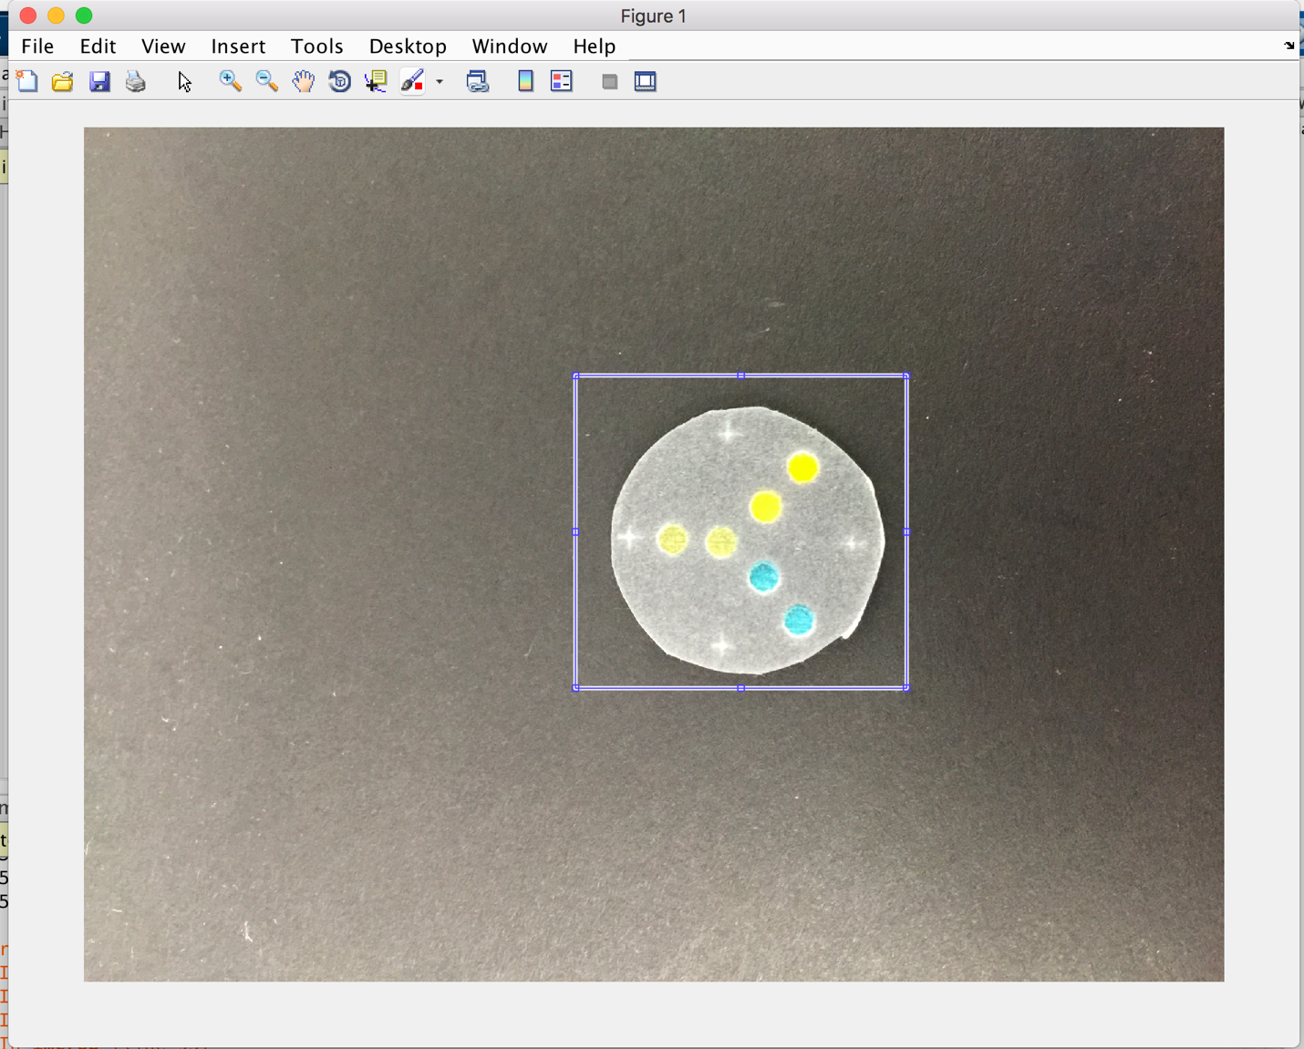

1. The program lets the user crop around the relevant region of the image.

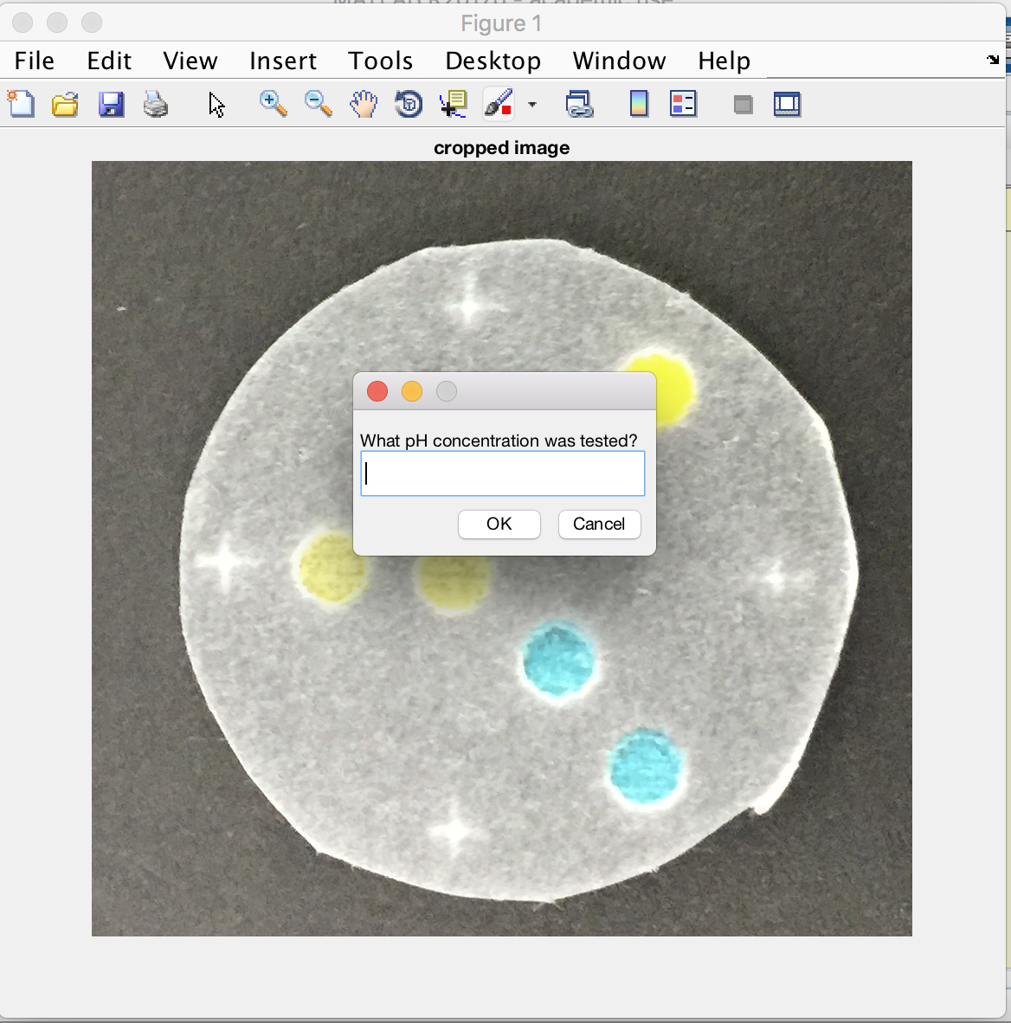

1. The program asks user for the pH that the patch was treated with.

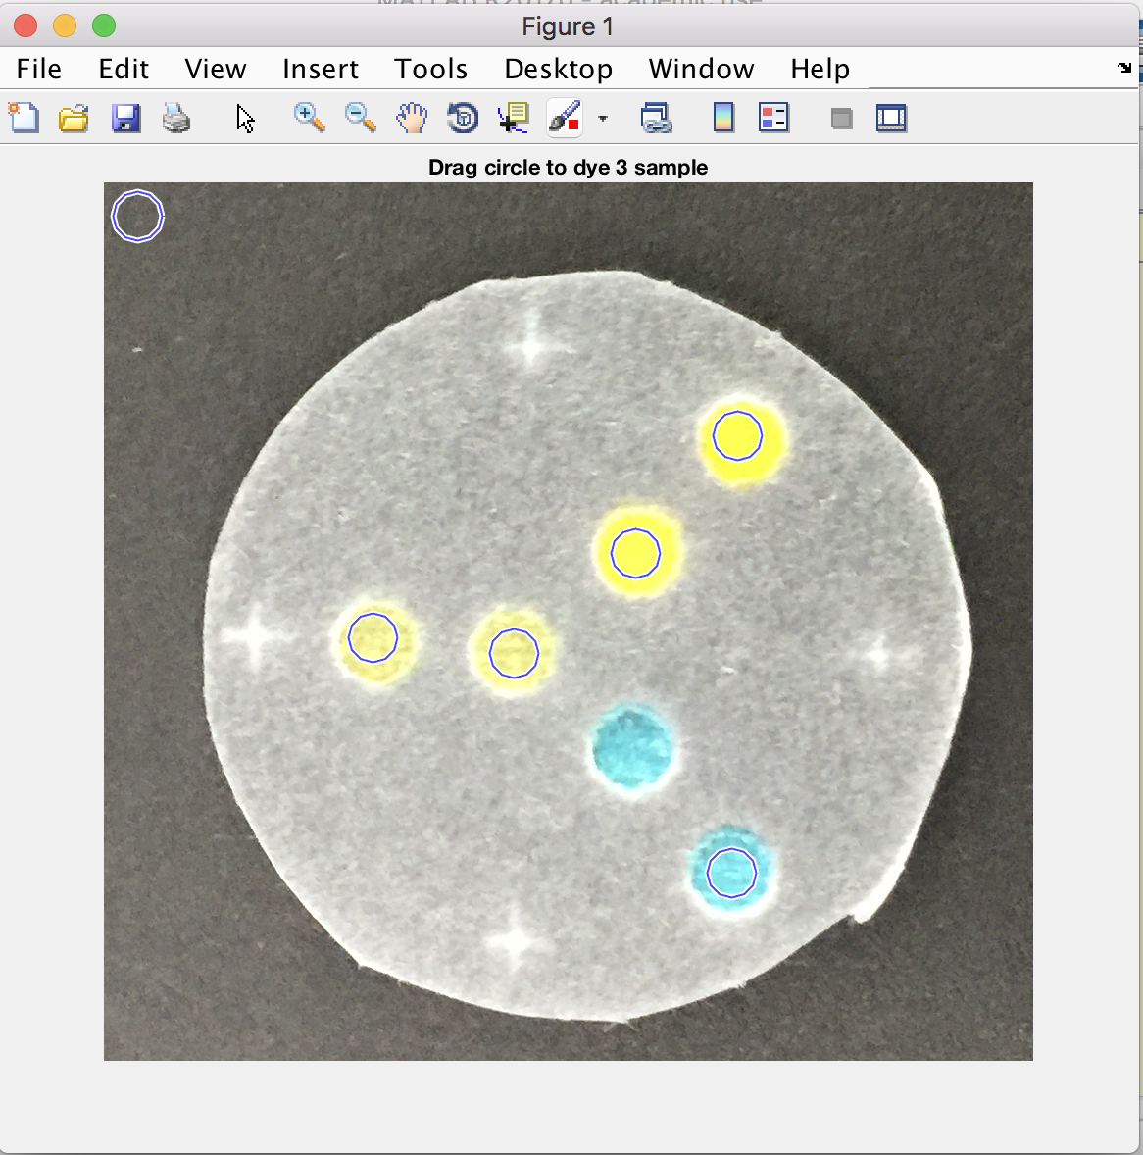

1. The user drags the circle of determined size to the pools which contain the pH sensitive dyes.

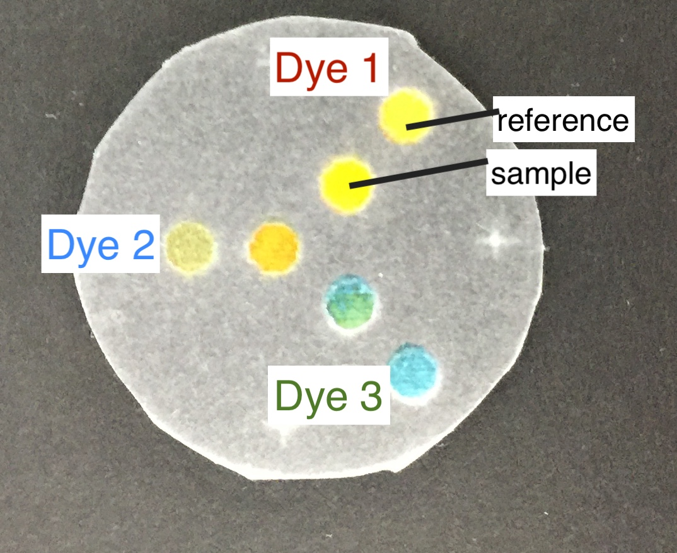

For reference, this is the sweat-pH sensitive patch looks like.

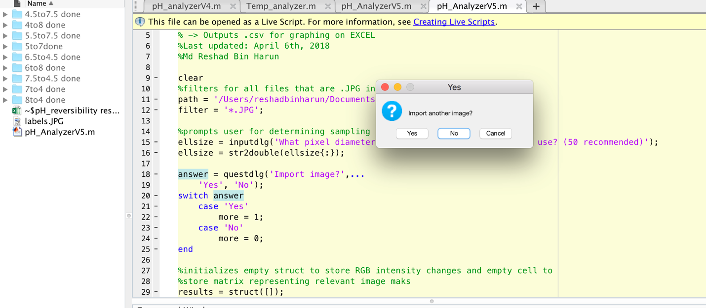

1. The user is asked to import as many images as they like.

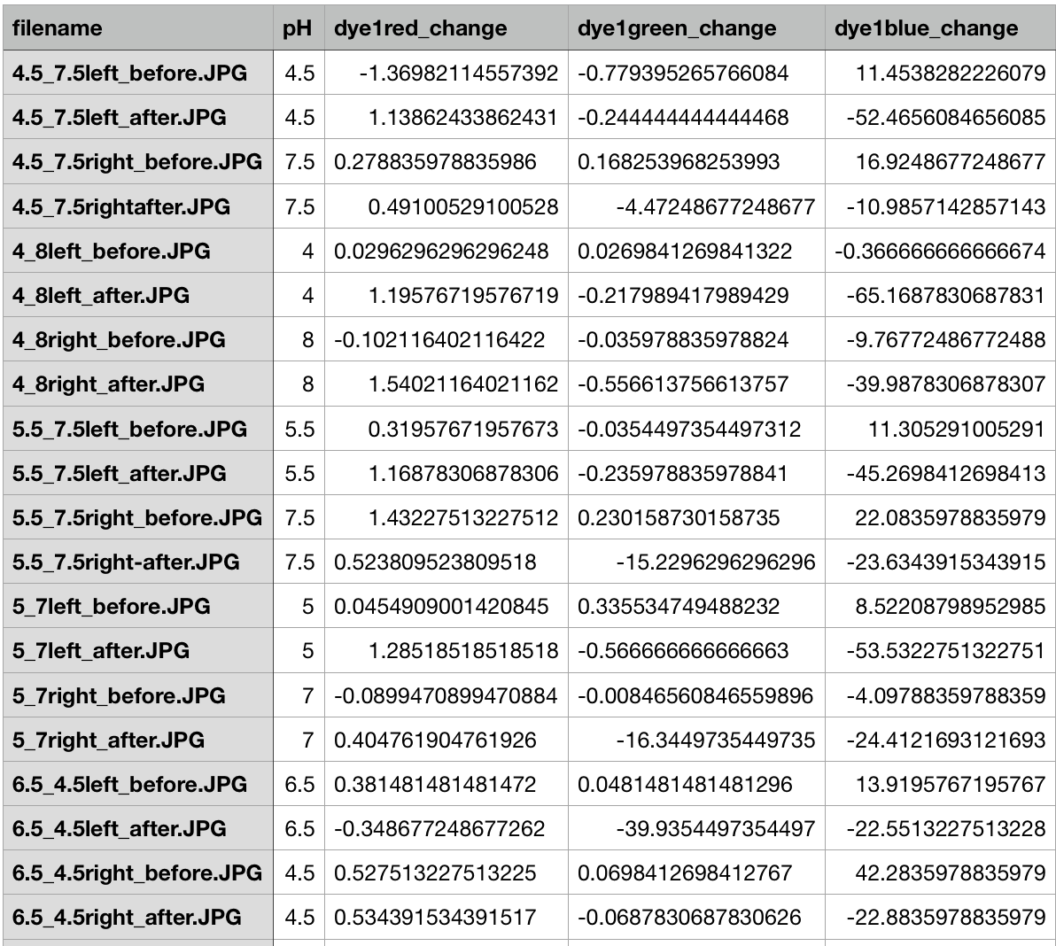

1. The program tabulates RGB channel changes for different pH treatments and exports it in .csv format.